Bug 1
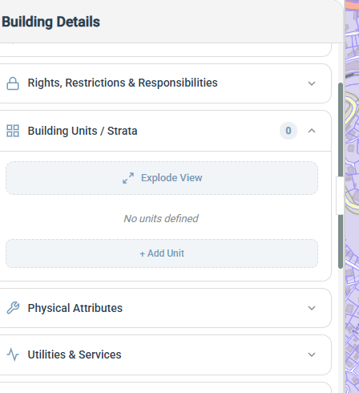cant add building unit.

Bug 2
cant change size this side menu

Bug 3

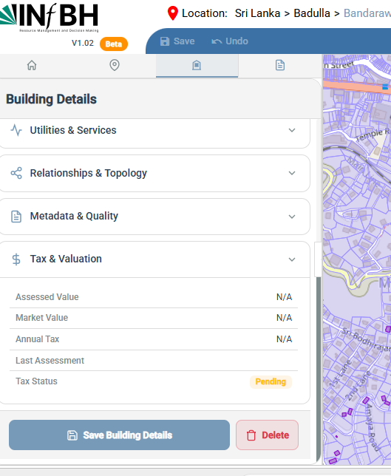cant scroll tax & valuation bar

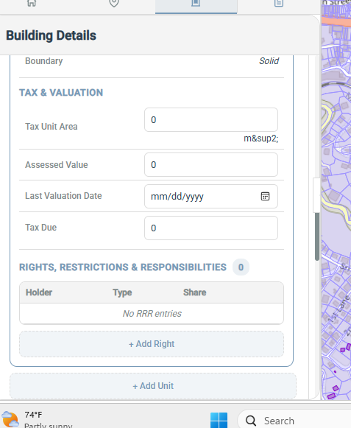
Bag 4
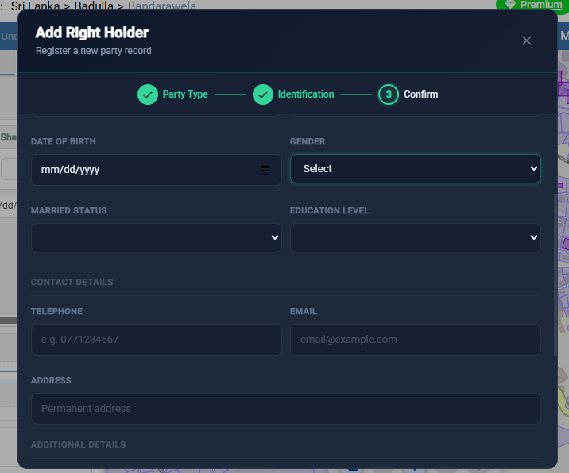
When adding right cant select( no selection attribute) gender , maried status like this features

Further there are issues with admin and superpadmin pannels,
- In admin panel I aneed to go and comeback to be visible the all the side pannels button
- I the super admin panel creation of new organizations, vissbelity of existing projects
Could you please let me know your plan of remobving these issues and then we can execure one by one

